Kapture - MDM (Master Data Maintenance) SI VIN Ranges Unit Test Cases

Contents
1. User System Access 3
2. SI VIN Range (MC) 3
3. SI InnerLinks Validation Reports 18
4. Schedule Maintenance VIN Mapping 20

Kapture - MDM (Master Data Maintenance) - SI VIN Ranges
Unit Test Cases
Application URL: https://na.dev.mgss.oc.mazda.com/mdmgt
Application: mdmgt.war (/mdmgt) | Version: v2 | Date: 16-Oct-2026
- Unit Test Case Summary:
# | Test Cases Processes | No. of Test Cases | No. of Success | No. of Failure | Status
1 | User System Access | 1 | 1 | 0 | Pass
2 | SI VIN Range (MC) | 11 | 11 | 0 | Pass
3 | SI InnerLinks Validation Reports | 1 | 1 | 0 | Pass
4 | Schedule Maintenance VIN Mapping | 3 | 3 | 0 | Pass
 | Total | 16 | 16 | 0 | Pass

User System Access
- User should be able to open MDM and view the SI VIN Ranges tab on My Page.
Steps:
1. Log in to MGSS with a valid user.
2. Open the URL: https://na.dev.mgss.oc.mazda.com/mdmgt
3. Click the SI VIN Ranges tab.
Expected Result: The tab lists the tiles MNAO VIN Range, MC SI VIN Range, MME SI VIN Range, SI InnerLinks Validation Reports and Schedule Maintenance VIN Mapping.
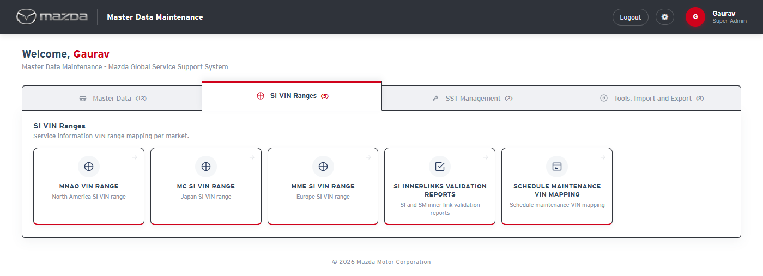
My Page - SI VIN Ranges tab
Status: Pass
Remarks:

SI VIN Range (MC)
The SI VIN Range screens map VIN ranges to Service Information documents in Kapture. The cases below are executed on MC SI VIN Range with Country Code Japan, Language Japanese and SI Doc Id SI1077. MNAO VIN Range and MME SI VIN Range work in the same manner (search document, add VIN / preview, import, export, delete, SI VIN Schedule) with their own market selections, and have been tested.
- User should be able to open the MC SI VIN Range screen.
Steps:
1. From My Page > SI VIN Ranges, click MC SI VIN Range.
Expected Result: The screen shows Country Code, Language and SI Doc Id with Search / Clear, and the Add VIN, Import VIN Details and Document Details sections.
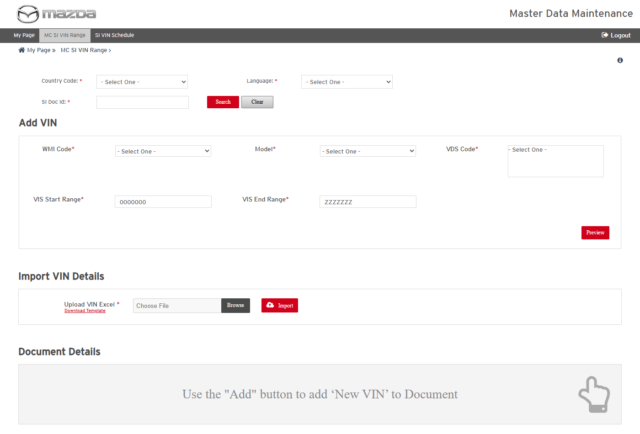
MC SI VIN Range screen
Status: Pass
Remarks:

- System should not search a document without the mandatory fields.
Steps:
1. Select Country Code Japan only.
2. Click Search.
Expected Result: "Please fill all the fields marked as mandatory (*)." is shown.
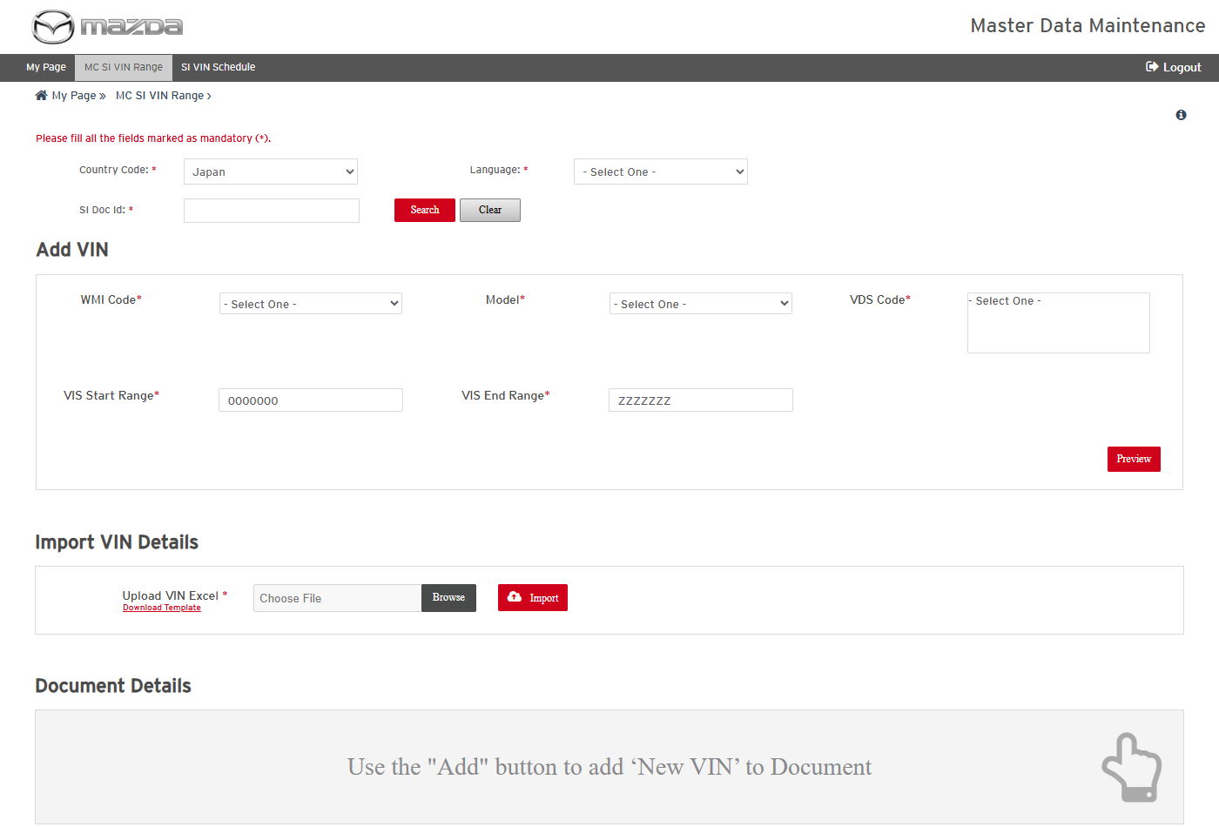
Mandatory field message
Status: Pass
Remarks:

- User should be able to search an SI document and view its VIN ranges.
Steps:
1. Select Country Code Japan and Language Japanese.
2. Enter SI Doc Id SI1077.
3. Click Search.
Expected Result: Document Details lists the VIN ranges mapped to SI1077 (27 rows: Document Id, Model, Carline Code, WMI Code, VDS Code, VIS Start / End Range).
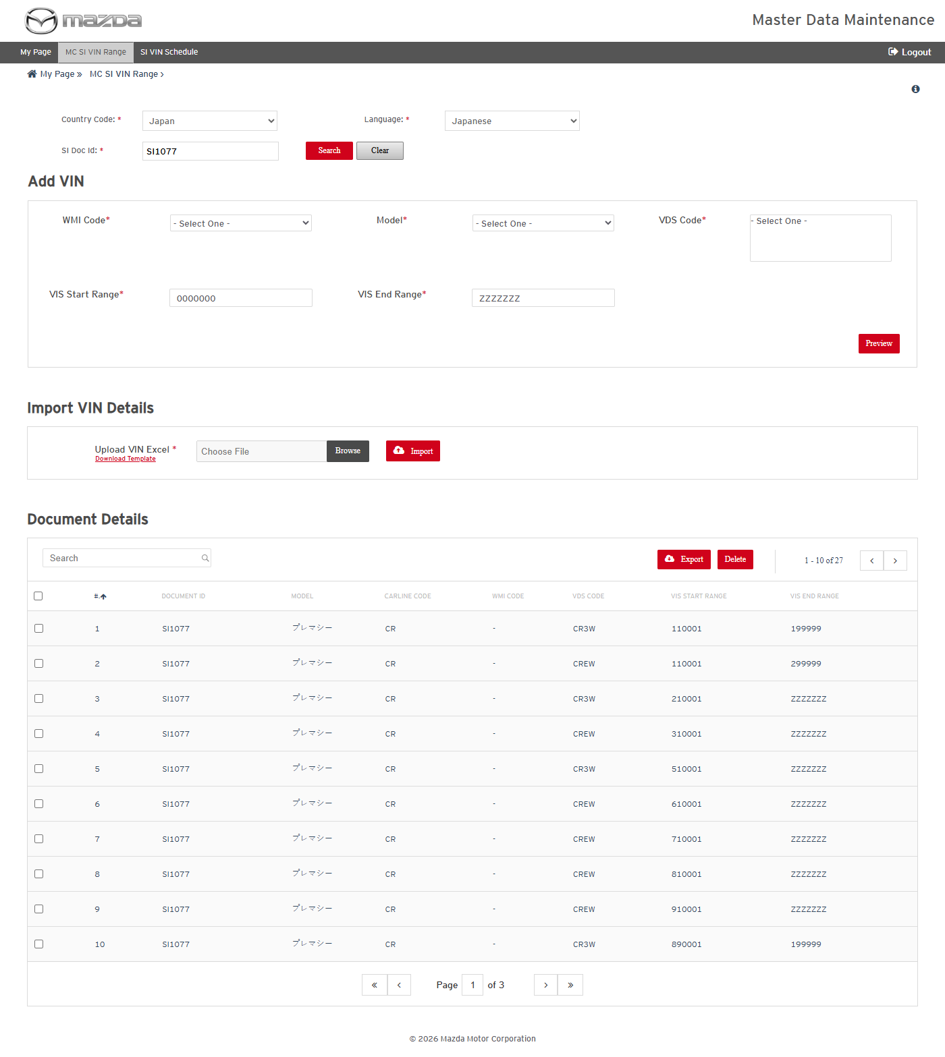
Document Details for SI1077
Status: Pass
Remarks:

- User should be able to export the VIN ranges of a document.
Steps:
1. Click Export without selecting any row.
2. Select all rows and click Export.
3. Open the exported Excel.
Expected Result:
- "Please select at least 1 row to Export." is shown when no row is selected.
- The Excel lists the selected VIN ranges with the same columns as the screen.
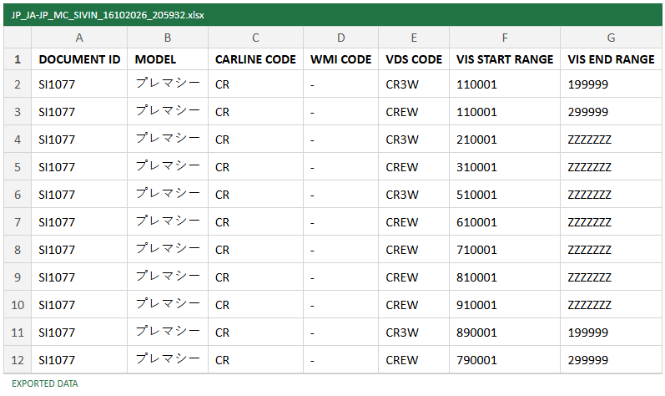
Exported Excel
Status: Pass
Remarks:

- User should be able to preview a new VIN range before adding it.
Steps:
1. In Add VIN, select WMI Code -, Model PREMACY CR and VDS Code CR3W.
2. Enter VIS Start Range 990001 and VIS End Range 999999.
3. Click Preview.
Expected Result: Preview VIN lists the new range (CR / - / CR3W / 990001 / 999999) with Add VIN and Reset buttons.
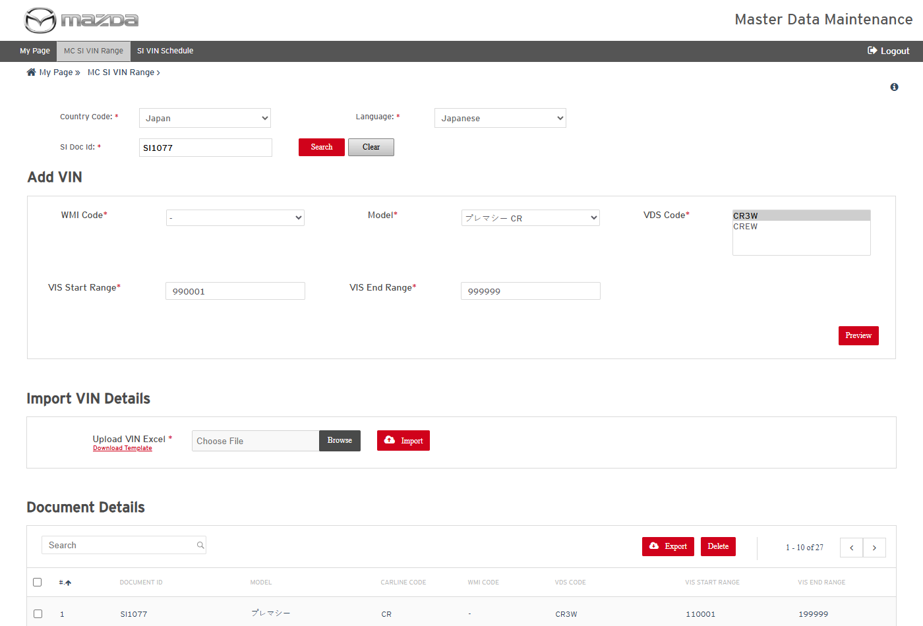
Add VIN values
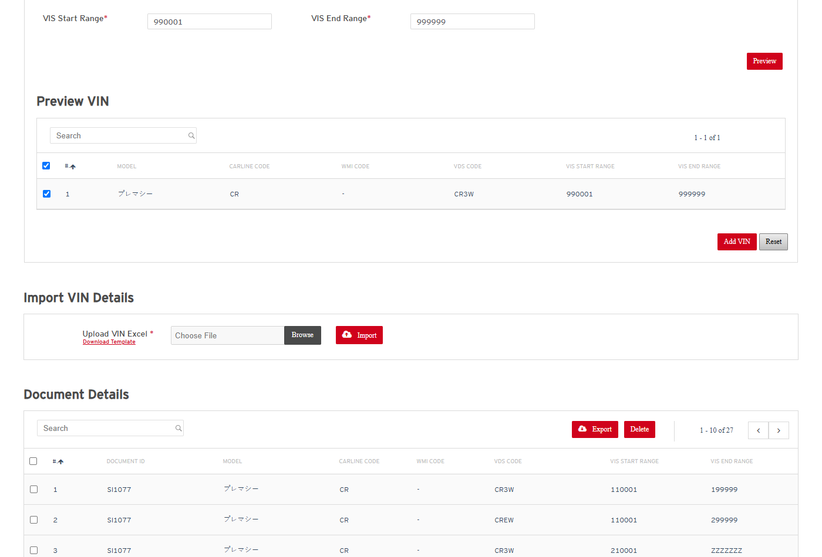
Preview VIN
Status: Pass
Remarks:

- User should be able to add the previewed VIN range to the document.
Steps:
1. Keep the preview row selected and click Add VIN.
Expected Result: "VIN(s) successfully mapped with the Document Id - SI1077." is shown and the document is updated in Kapture with the new VIN range.
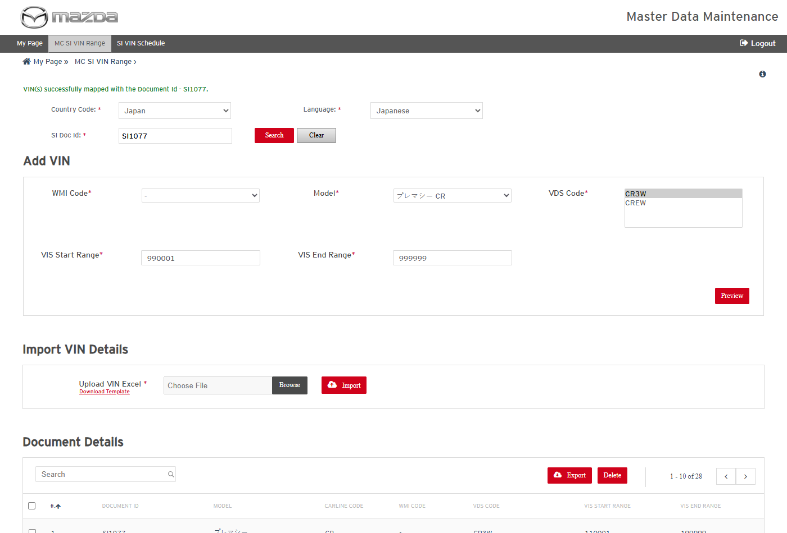
VIN mapped to SI1077
Status: Pass
Remarks:

- User should be able to import VIN ranges from Excel; a large import runs as an SI VIN Schedule.
Steps:
1. Click Download Template and fill six VIN ranges (CR / - / CR3W / 910001-919999 to 960001-969999).
2. Choose the Excel in Upload VIN Excel and click Import.
3. Click Ok on the dialog.
Expected Result:
- More than five VIN ranges are processed as a scheduled job: "MGSS_SIVIN_MC_1024 scheduled successfully." is shown.
- Ok opens the SI VIN Schedule page with the job listed.
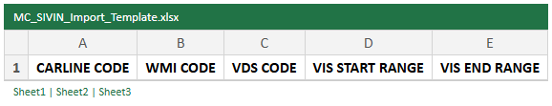
Import template
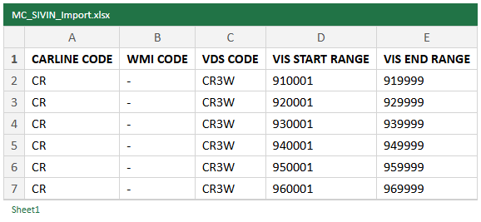
Import file - six VIN ranges
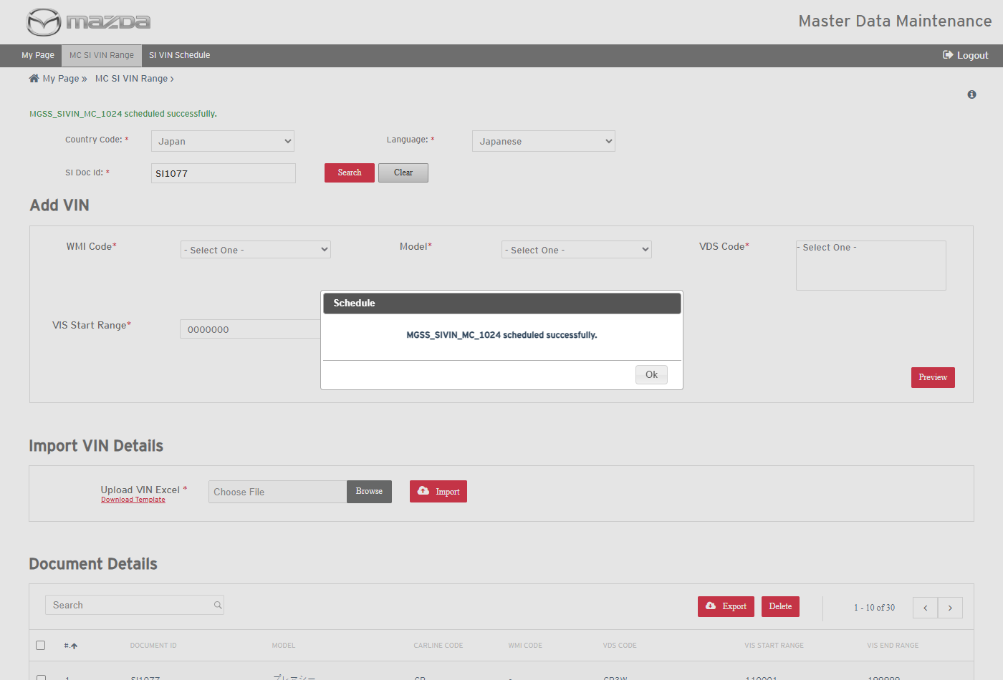
Job scheduled
Status: Pass
Remarks:

- User should be able to view the SI VIN Schedule and download its reports.
Steps:
1. Open SI VIN Schedule from the top menu.
2. Click the download icon of MGSS_SIVIN_MC_1024.
3. Open the reports in the zip.
Expected Result:
- The job shows Locale ja_JP, Document Id SI1077, VIN Operations 6 / 6 / 0, VIN Mapped 6 / 6, Document Status Success and Schedule Status Completed.
- The Category Creation report lists the VIN categories created with status Success; the Modification report lists each VIN range mapped to SI1077 with Kapture and DB status Success.
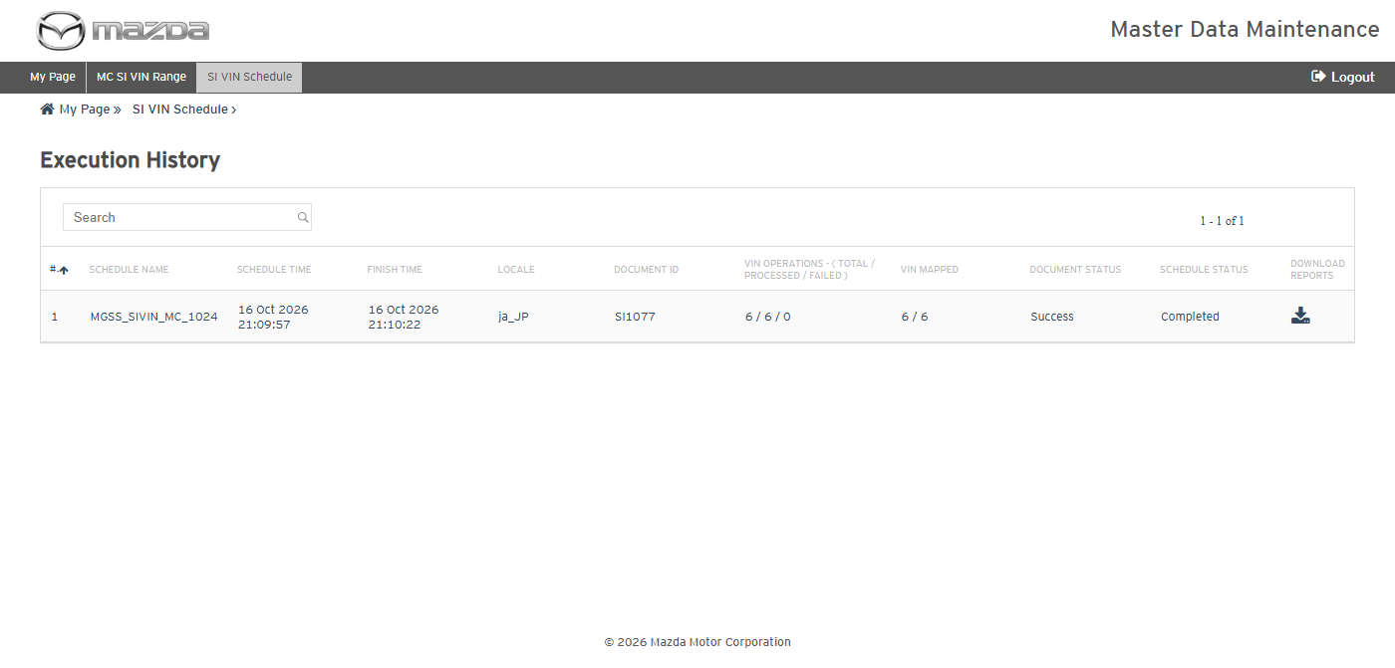
SI VIN Schedule - job completed
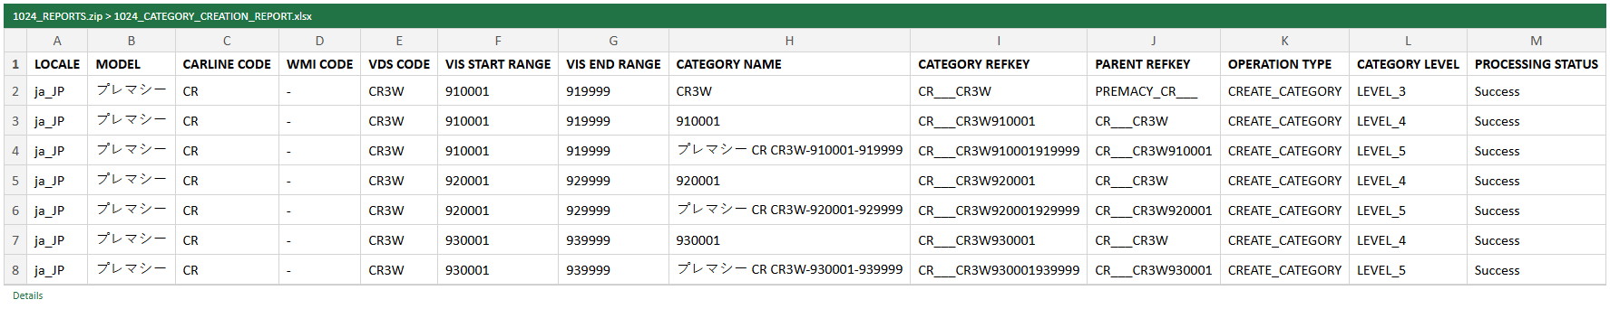
Category Creation report
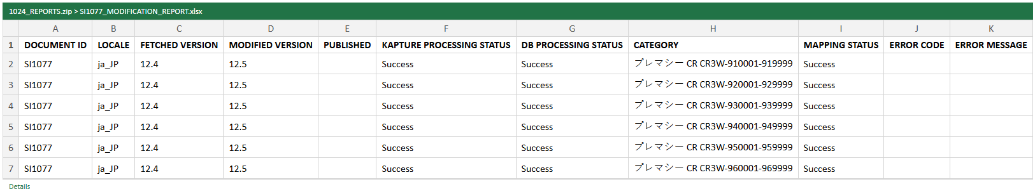
SI1077 Modification report
Status: Pass
Remarks:

- Added VIN ranges should be listed in the document details.
Steps:
1. Search SI1077 again.
2. Filter Document Details on CR3W.
Expected Result: The document now has 36 VIN ranges; the ranges added from the screen and the import are listed.
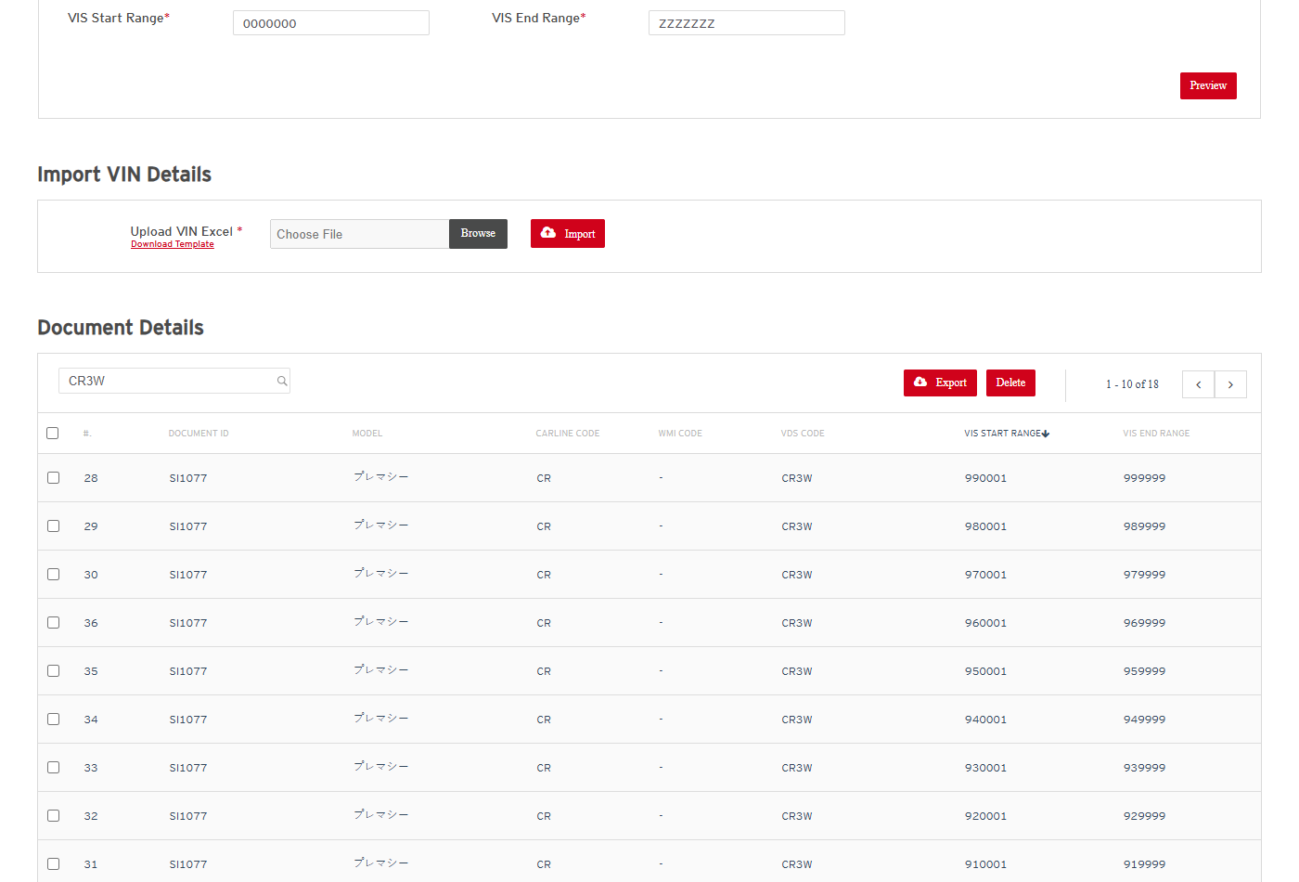
New VIN ranges on SI1077
Status: Pass
Remarks:

- User should be able to delete VIN ranges from the document.
Steps:
1. Select the nine VIN ranges added above.
2. Click Delete and click Yes on the confirmation.
Expected Result:
- A confirmation dialog is shown.
- "VIN(s) successfully deleted from the Document Id - SI1077." is shown and the document is back to 27 VIN ranges.
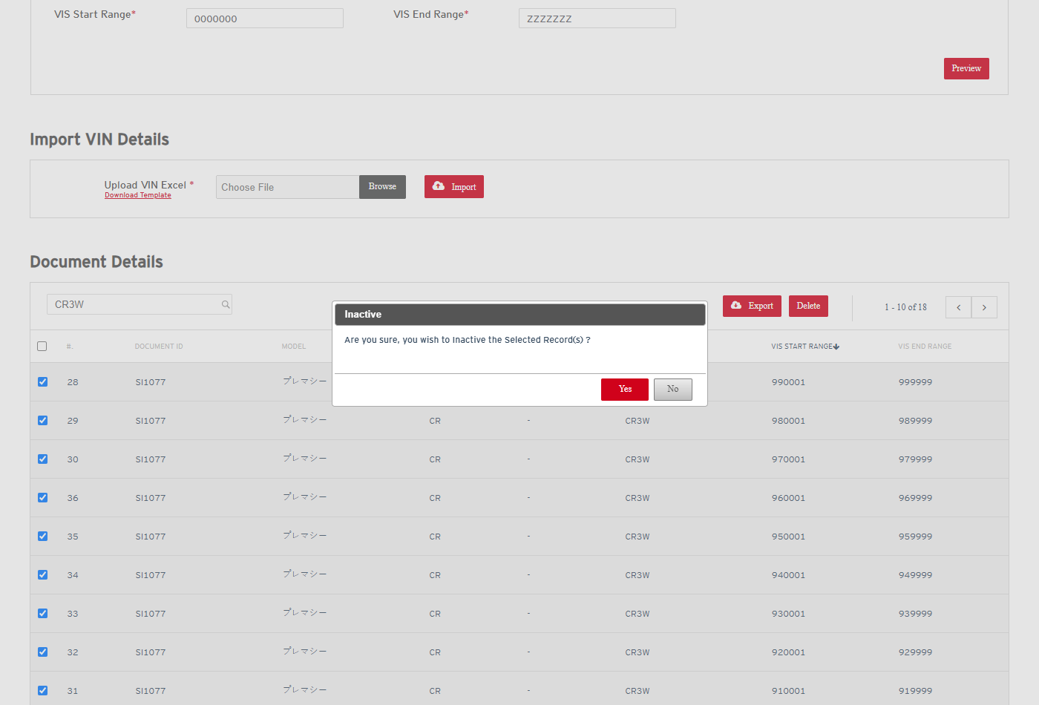
Delete confirmation
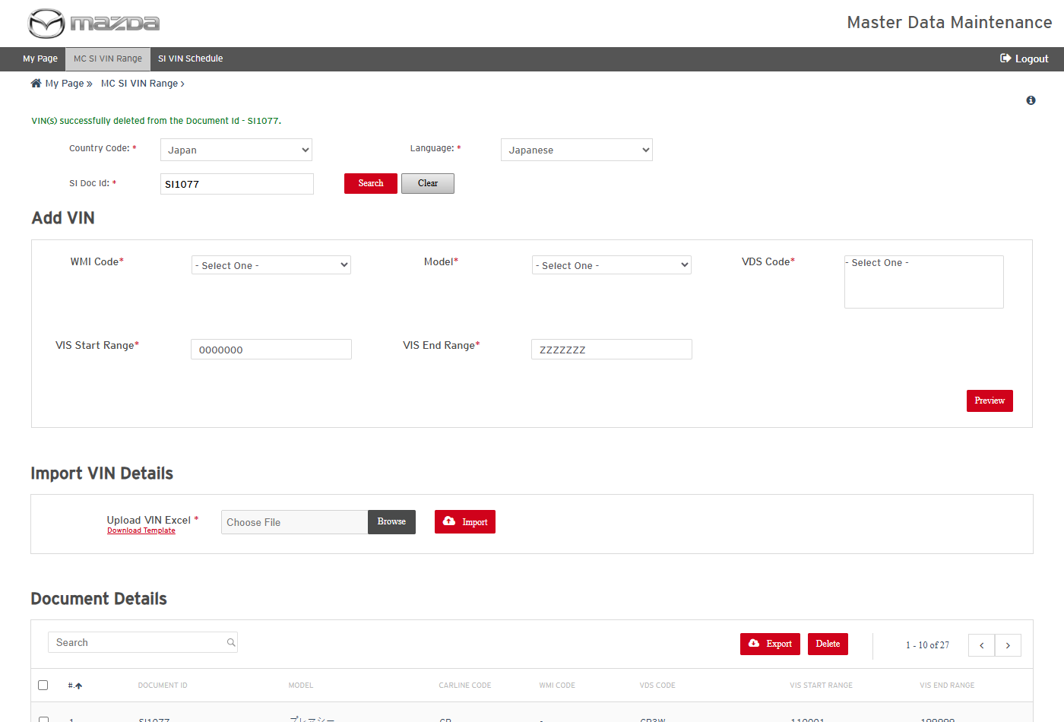
VIN ranges deleted
Status: Pass
Remarks:

- MNAO VIN Range and MME SI VIN Range screens should work in the same manner as MC.
Steps:
1. From My Page > SI VIN Ranges, open MNAO VIN Range and MME SI VIN Range.
Expected Result: Both screens offer the same search, Add VIN, Import and Document Details functions with their market selections (MNAO: Year From / To; MME: Engine Type / Transmission Type). Tested in the same manner as MC.
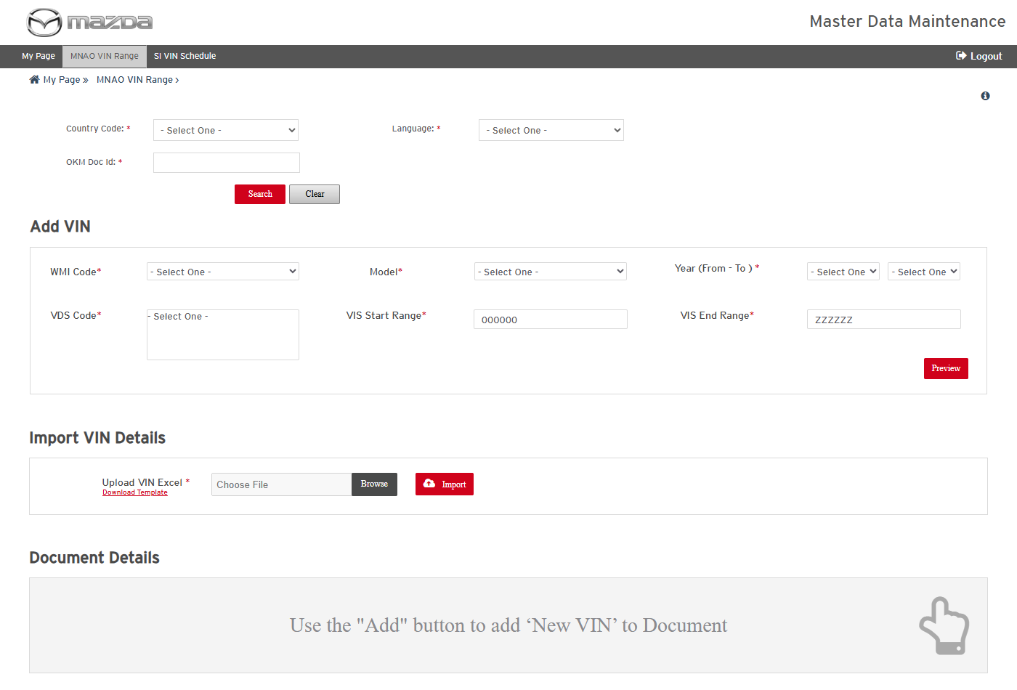
MNAO VIN Range
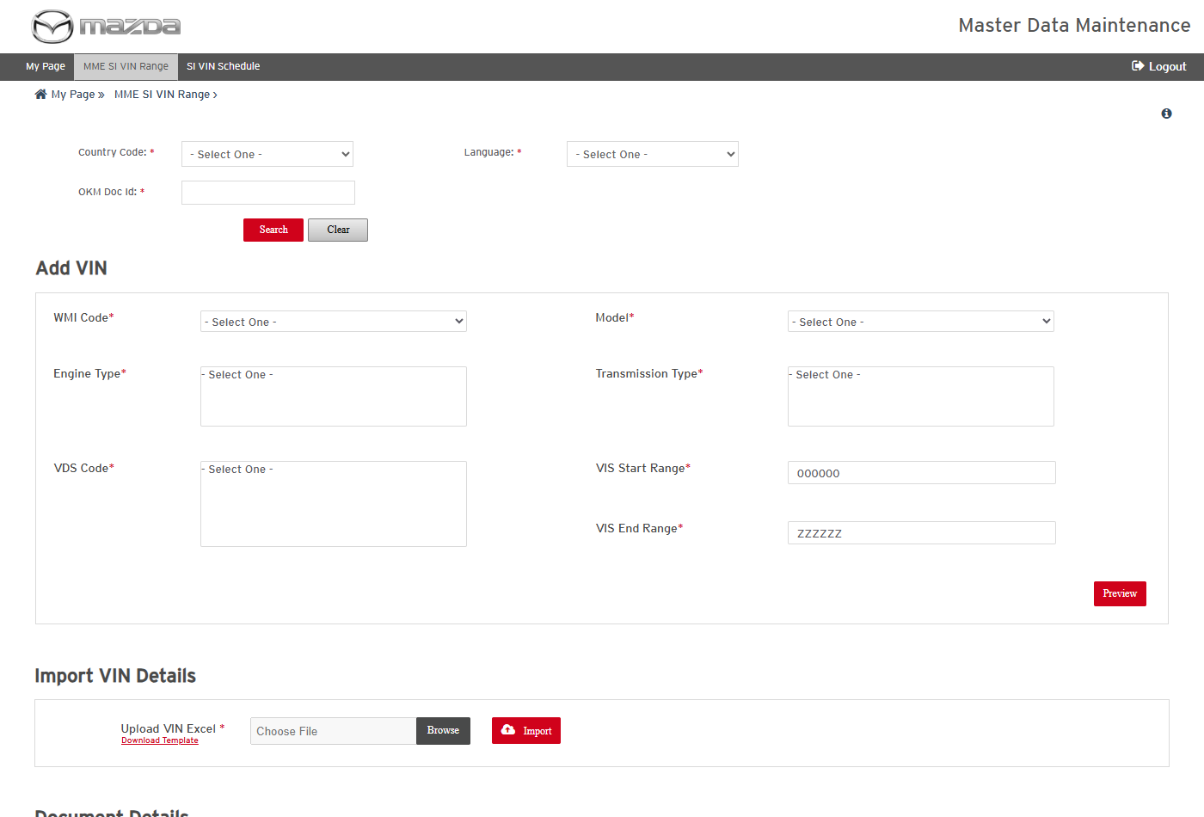
MME SI VIN Range
Status: Pass
Remarks:

SI InnerLinks Validation Reports
- User should be able to view the SI InnerLinks validation history and its reports.
Steps:
1. From My Page > SI VIN Ranges, click SI InnerLinks Validation Reports.
2. Click the View Reports icon of a schedule.
Expected Result:
- Execution History lists each schedule with schedule / finish time, document and SM innerlink counts, schedule status and job status.
- The Reports dialog lists the report per locale with a download icon.
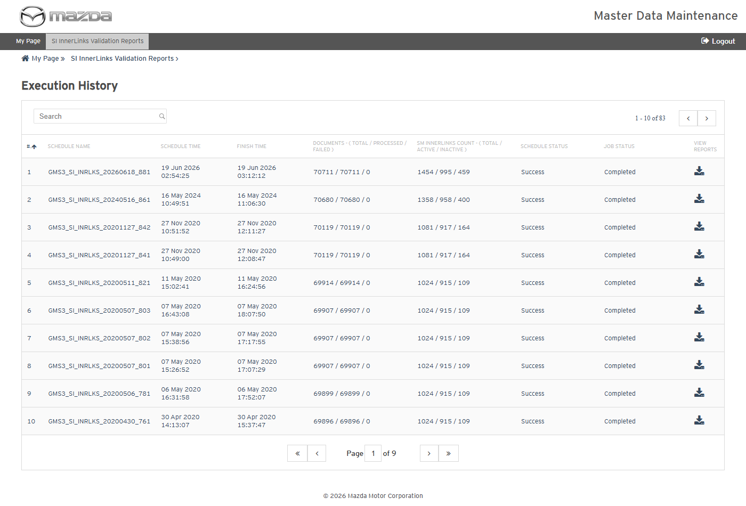
Execution History
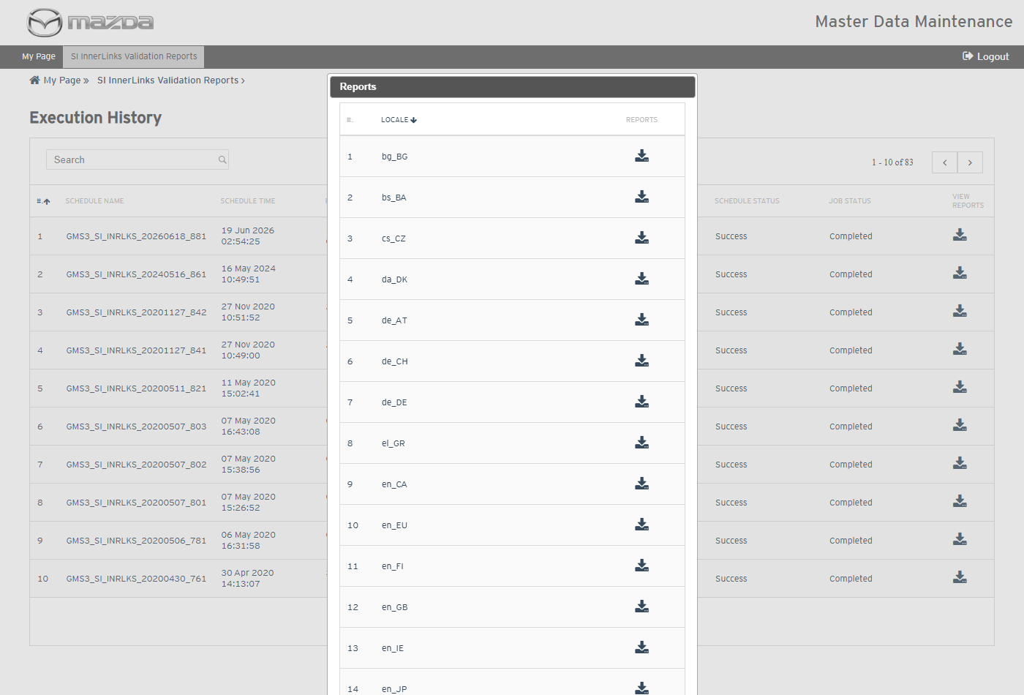
Reports per locale
Status: Pass
Remarks:

Schedule Maintenance VIN Mapping
- User should be able to view and export the Schedule Maintenance VIN mappings.
Steps:
1. From My Page > SI VIN Ranges, click Schedule Maintenance VIN Mapping.
2. Click Export.
3. Open the exported Excel.
Expected Result:
- Schedule Maintenance VIN Mapping Details lists the mappings (170 rows).
- The Excel lists Locale, Model, Carline, WMI, VDS, VIS range, Document Id / Title and source file.
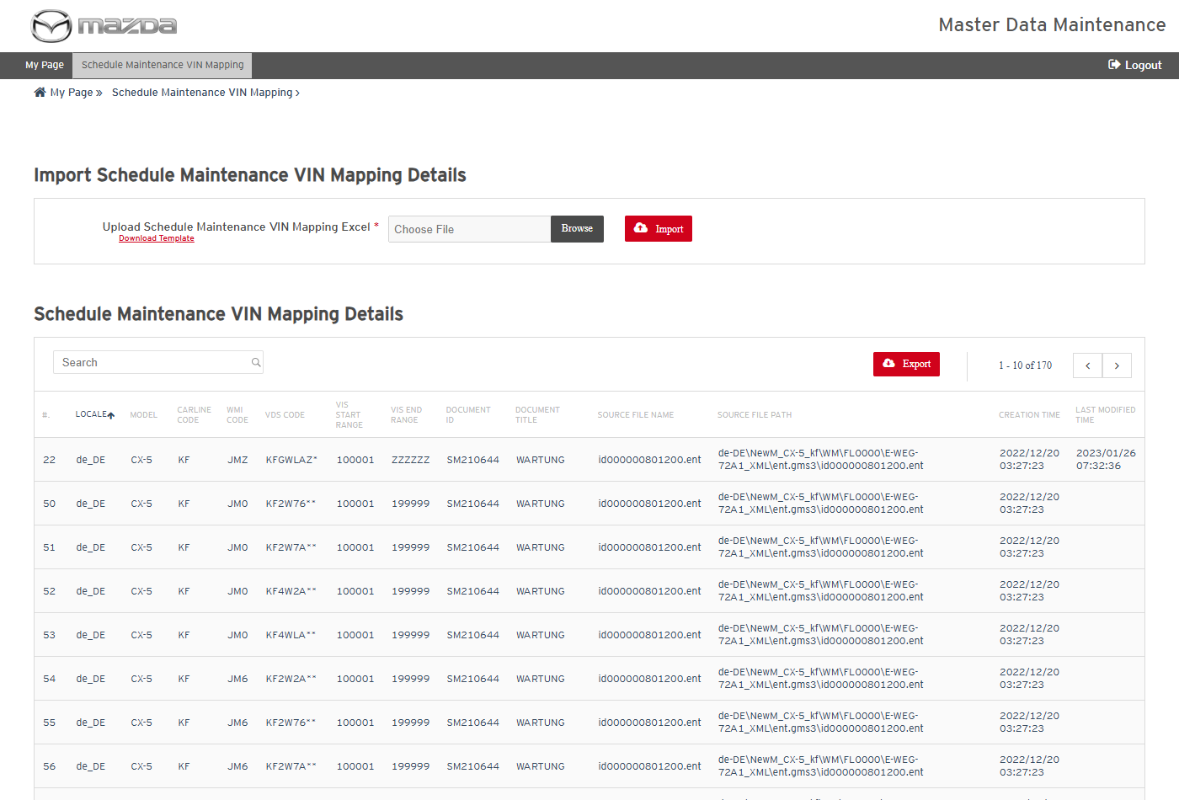
Schedule Maintenance VIN Mapping
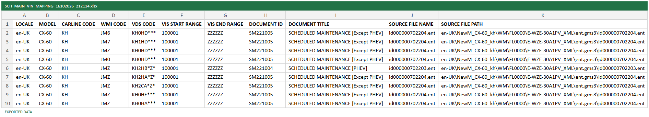
Exported Excel
Status: Pass
Remarks:

- System should not import without an Excel file.
Steps:
1. Click Import without choosing a file.
Expected Result: "Please upload a valid Excel file." is shown.
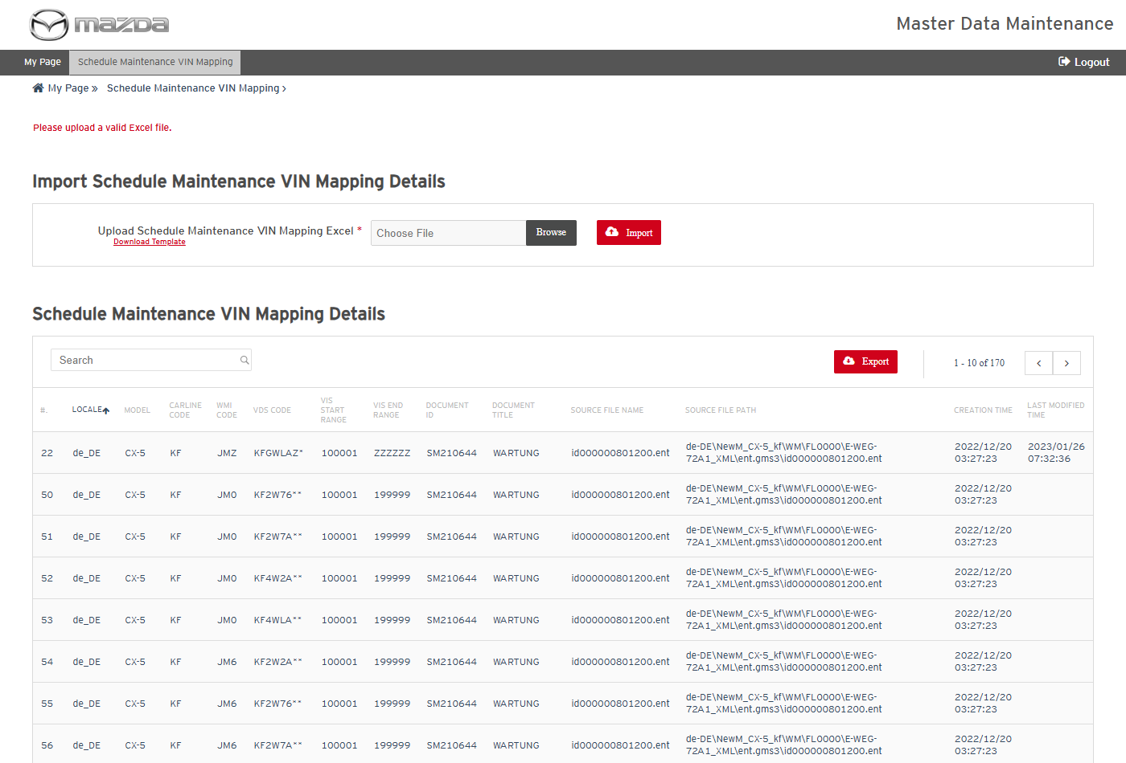
Validation message
Status: Pass
Remarks:

- User should be able to import Schedule Maintenance VIN mappings.
Steps:
1. Click Download Template and fill a mapping (de_DE / KF / JM0 / KF2W76 / 100001 / 199999 / source file path).
2. Choose the Excel and click Import.
Expected Result: "1 rows successfully imported." is shown; the existing mapping is updated (Last Modified Time set) and no duplicate row is created (still 170 rows).
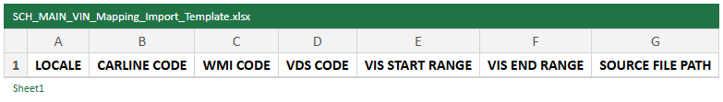
Import template
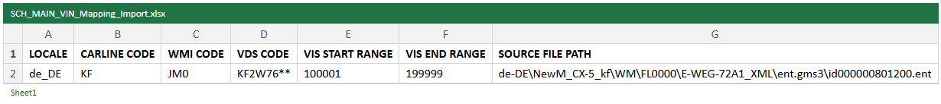
Import file
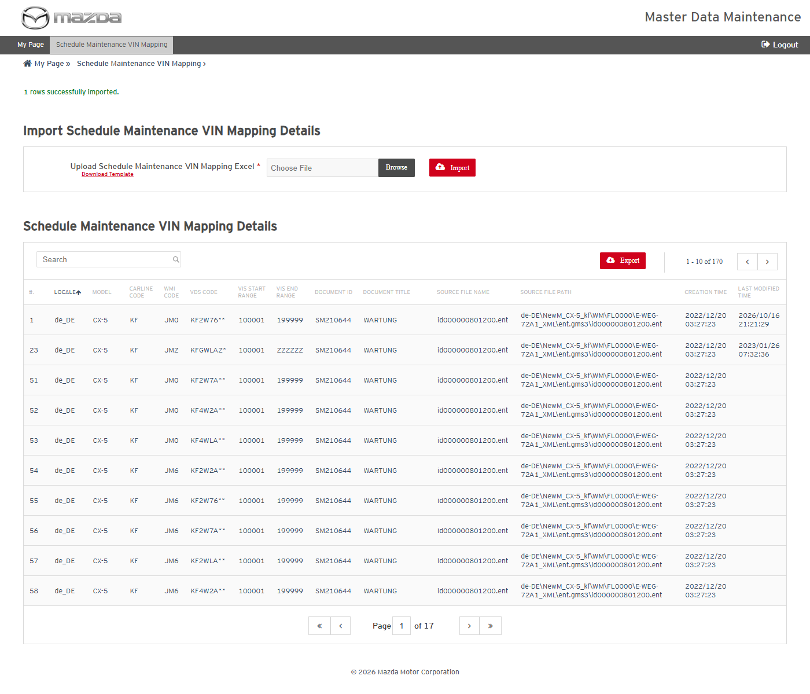
Import result
Status: Pass
Remarks:

